**Meta Data for 2012 North Pole Environmental Observatory CTD-O2 Profiles collected as part of the aerial hydrographic surveys**

Measurements were collected using two Seabird SBE19*plus* Seacats (serial numbers 5076 and 4000), each outfitted with an SBE43 O2-sensor (serial numbers 0229 and 1406, respectively). The SBE43 sensors were plumbed in-line between the TC cell and Seabird 2.0K pump of each instrument. The CTD-O2 package was hung below an in-situ ultraviolet spectrophotomer (ISUS) and battery pack, mounted vertically in a stainless steel frame, using 4-inch, locking carabiners. During Casts 1-12, the ISUS was fitted with a sample volume accessory allowing the pumped seawater outflow from the CTD-O2 package to be routed directly to the optical probe of the ISUS via a ~0.9 m length of Tygon tubing. As a consequence of the physical separation between the thermistor and O2 sensor (as well as the different response times of the two sensors), there is a small lag in time between temperature and O2 measurements of the same water parcel. Similarly, there is a longer lag between temperature and nitrate measurements made by the ISUS. As a result, the O2 and NO3 data must be “advanced” in time such that the conductivity (salinity), temperature, oxygen, and nitrate data are correctly aligned relative to pressure. The stations occupied during the 2012 field season of the North Pole Environmental Observatory as well as a summary of the advances computed to properly align the O2 data are listed in Table 1. The complete suite of NPEO 2012 CTD data has been archived separately at CADIS. The files described below can be obtained at: <http://cdp.ucar.edu/browse/browse.htm?uri=http://dataportal.ucar.edu/metadata/cadis/cadis.thredds.xml>. Further details regarding the alignment of the ISUS nitrate profiles are included in a separate README file accompanying those data.

Casts were begun by lowering the instrument package to a depth of ~15 meters to allow the instruments to come to ambient temperature while attempting to prevent any slush ice being pumped into the system. The package was then brought back up to the near surface and six Niskin bottles were attached to the hydrowire at successive intervals in order to sample the seawater at different target depths (20, 50, 75, 100, 150, and 300 m). Once the Niskin bottles are in position, a soak time of 5 minutes is allowed before tripping the bottles via messenger. The bottles are brought back up to the surface and sub-sampled for a variety of chemical variables. This portion of the cast is referred to as the “bottle cast” and is removed from the archived data files. Once the last Niskin bottle is removed from the hydrowire the winch is re-zeroed while the instrument package is near the surface. The package is then lowered through the water column. This portion of the data record is referred to as the “downcast”. Once the package reaches 800-900 m, the winch is stopped and the package is brought back up to the surface. This portion of the cast is referred to as the “upcast”. The initial parts of the data during which the CTD was lowered, equilibrated, and raised to the surface have been truncated from the final data files. The final data set reported for each station set consists of either downcast or upcast data according to the quality of the data collected (see Table 1).

**Table 1.** Summary of CTD-O2 data collected during 2012 season of the North Pole Environmental Observatory. Advances of temperature and oxygen represent the time (seconds) necessary to shift the corresponding records (relative to pressure) such that the downcast and upcast data are superimposed. Further details regarding the calculation of the advances are given in the text. Gray bars highlight data collected using CTD-O2 package 4000-1406 whereas all other data collected using the 5076-0229 package.

|  |  |  |  |  |  |  |  |
| --- | --- | --- | --- | --- | --- | --- | --- |
| Cast | Date | Station | CTD Package | Temp. Adv. | O2 Adv. | Applied O2 Adv. | Cast Reported |
| 1 | 04/16/12 | Brno 1 | 5076-0229 | 1.25 | 3.75 | 2.50 | down |
| 2 | 04/16/12 | 85N, 90E | 5076-0229 | 1.25 | 4.50 | 2.50 | down |
| 3 | 04/16/12 | 86N, 90E | 5076-0229 | 1.25 | 3.50 | 2.50 | down |
| 4 | 04/17/12 | 85N, 170W | 5076-0229 | 1.25 | 4.00 | 2.50 | down |
| 5 | 04/17/12 | 86N, 175W | 5076-0229 | 2.00 | 4.25 | 2.50 | down |
| 6 | 04/18/12 | 88N, 180 | 5076-0229 | 1.50 | 6.25 | 2.50 | up |
| 7 | 04/18/12 | Brno 2 | 5076-0229 | 1.50 | 7.50 | 2.50 | up |
| 8 | 04/19/12 | 87N, 180 | 5076-0229 | 1.25 | 6.25 | 2.50 | up |
| 9 | 04/19/12 | 89N, 180 | 5076-0229 | 1.00 | 6.00 | 2.50 | up |
| 10 | 04/20/12 | 87N, 90E | 5076-0229 | 1.50 | 6.50 | 2.50 | up |
| 11 | 04/20/12 | 88N, 90E | 5076-0229 | 1.00 | 6.50 | 2.50 | up |
| 12 | 04/21/12 | Brno 3 | 5076-0229 | 1.50 | 5.50 | 2.50 | up |
| 12b | 04/21/12 | Brno 3 | 4000-1406 | 1.25 | 3.75 | 2.50 | down |
| 13 | 04/22/12 | NP | 5076-0229 | 1.00 | 6.50 | 2.50 | up |
| 13b | 04/22/12 | NP | 4000-1406 | 1.00 | 4.00 | 2.50 | down |
| 14 | 04/22/12 | 89N, 90E | 5076-0229 | 1.50 | 5.00 | 2.50 | down |
| 14b | 04/22/12 | 89N, 90E | 4000-1406 | 1.25 | 5.00 | 2.50 | down |
|  |  |  |  |  |  |  |  |
|  |  | ***AVG of Casts 1-5, 12b, 13b, 14b*** |  | ***1.30*** | ***4.10*** |  |  |
|  |  | ***AVG of Casts 6-14*** |  | ***1.30*** | ***6.20*** |  |  |

The 4 Hz raw data consisted of scan number, pressure, temperature (ITS-90), conductivity, and SBE43 oxygen sensor voltage. The data were processed using SBEDataProcessor (Version 7.12) according to the following steps:

(1) The raw data was converted using appropriate configuration (CON) file such that the output variables included time, pressure, temperature, conductivity, and SBE43 voltage. Hysteresis and tau corrections were applied to SBE43 voltage data with a 2-sec window.

(2) The temperature and conductivity data were then filtered using a 0.5 second low pass filter whereas the pressure and SBE43 voltage were smoothed using a 1.0 second low pass filter, in accordance with Seabird’s recommendations for SBE19 *plus* data processing.

(3) The temperature records were advanced 0.55 seconds with respect to pressure, as determined by Roger Andersen (APL-UW) on the basis of salinity spiking minimization (Seabird recommends an advance of 0.5 seconds due to the relatively slow response of the temperature sensor with respect to those of the conductivity and pressure sensors; it is possible the cold Arctic environment resulted in a slightly slower than usual sensor response). The SBE43 voltage was advanced 2.5 seconds relative to pressure to account for the lag time between the flow of the sample from the thermistor to the O2 sensor. Details regarding the calculation of the optimal O2 advancement time are given in the next section.

(4) Cell thermal mass corrections (alpha = 0.025, tau = 9.0) were applied.

(5) Additional variables were derived from the processed data, including depth (salt water, m) computed assuming a constant latitude of 87ºN, potential temperature (ITS-90, deg C), salinity, potential density (sigma-theta, kg m-3), and dissolved oxygen concentration (mL L-1). The oxygen concentration was calculated using the Murphy-Larson equation, incorporating a cubic temperature correction and a feature-sharpening term (*tau*) involving the time derivative of SBE43 voltage.

(6) For stations where the downcasts data were compromised (further details given in the next section), the upcast data were reported (Casts 6-14). For these casts, an additional advance was necessary to properly align the data acquired during the upcast relative to pressure. Typically, the movement of the instrument package upward through the water column during the upcast results in the displacement of water parcels immediately surrounding the instruments. This is referred to as the wake effect and results in an offset between data acquired during the downcast versus the upcast (relative to pressure). To correct for this wake effect, all derived variables (temperature, potential temperature, potential density, salinity, and dissolved oxygen) were advanced by an additional 3.0 seconds relative to pressure. This advance was computed as 2 x 1.5 sec., where the 1.5 sec. advance was determined as the mean advance necessary to superimpose the downcast and upcast temperature records (see Table 1). This advance is necessary because both the downcast and upcast records are shifted during the calculation of the 1.5 sec. advance. Therefore, the advance necessary to overlay the upcast and the initial downcast (prior to any advancement) is 1.5 + 1.5 = 3.0 seconds. In other words, the advanced upcast data should be aligned (relative to pressure) exactly as the downcast data.

*Determination of optimal O2 advance*

The SBE43 O2 sensor is located downstream of the temperature sensor. For this reason, the SBE43 O2 sensor voltage must be advanced relative to pressure such that the voltage readings correspond with the temperature and conductivity measurements recorded by the CTD for the same water volume. As noted above, hysteresis of temperature versus pressure is commonly observed when comparing downcasts and upcasts. This can result from a combination of factors such as the wake effect and internal waves that may vary from cast to cast.

The optimal advance was determined by visually aligning features exhibited in the temperature profiles (e.g., minima and/or maxima) between the downcast and upcast. For each iteration, the combined data record (downcast and upcast) was advanced between -10 and +10 seconds (in 0.25 second intervals) and the separate downcast and upcast profiles plotted against pressure. The advancement resulting in the best alignment was selected be eye and chosen as the optimal advance. In some cases visual alignment was difficult due to a lack of prominent features in the temperature record. Whenever this occurred, successive differences (i.e., Ti – Ti-1) were plotted versus pressure. Peaks in these differences, representing sudden large changes in temperature (e.g., thermocline, transition between layers of relatively warm and cold waters) were visually aligned to determine the optimum advance. Comparisons of these two methods consistently returned similar results. An identical procedure was applied to the SBE43 voltage resulting in the coincidence of the downcast and upcast dissolved oxygen concentrations for each cast. The determined advances for temperature and O2 are listed in Table 1.

In principle, the SBE43 sensor voltages are subject to the same advance (wake effect plus internal waves) as the temperature plus an additional advance that accounts for the lag time between temperature and O2 measurements resulting from the physical separation between the sensors. Therefore, the **advance applied to the SBE43 sensor voltage during data processing was equal to the difference between the O2 advance minus the temperature advance.**

*Problems with Casts 6-14*

The 5076-0229 CTD-O2 package recorded quality oxygen data on both the downcast and upcast during Casts 1-5; therefore the downcast data are reported for these casts. However, a negative bias was observed during the downcasts of Casts 6-14 that was not encountered in the upcast data records (Fig. 1). We do not have a satisfactory explanation for the cause of the sensor bias during these casts. However, we did observe a significant increase in the offset between downcast and upcast NO3 profiles recorded by the ISUS that was coincident with the biased O2 data. Assuming these two issues are linked, we have outlined the following hypothesis. We speculate that slush ice may have been introduced into the sample stream when the instrument package was brought to the near surface following the bottle cast and just prior to the downcast. We further suggest this ice blocked or slowed exchange through the O2 sensor membrane. Dissolved oxygen in seawater must diffuse through the sensor membrane to react with an internal electrode, resulting in the donation of electrons. The donation of four electrons per molecule of oxygen is counted per second, recording a voltage that is calibrated to determine the oxygen concentration of the seawater sample. The sensor requires flushing in order to record accurate data; therefore, the lower O2 recorded during the downcasts may have therefore resulted from slush ice interfering with exchange through the sensor membrane. As the instrument package moved deeper through the water column, the increase in pressure and temperature likely melted the ice, clearing obstructions to the membrane and improving the flow rate. Hence, the upcasts were unaffected by this issue and returned quality measurements.

If seawater flow was reduced through the CTD-O2 system, the reduced flow might have been exacerbated along the length of Tygon tubing connecting the ISUS to the CTD-O2 outflow, resulting in the larger offset observed between downcast and upcast NO3 profiles. However, if such a reduction in flow did occur, one would expect a certain degree of smearing in the downcast NO3 data as well as a longer lag (higher advance) between temperature and NO3 measurements collected during the downcast versus those collected during the upcast. Examination of the data did not reveal any obvious smearing or significant differences in flow rates; however, such investigations were quite difficult with the available data and we therefore must admit that such attempts were not conclusive. There are a number of alternative explanations that might account for the negative bias in the downcast O2 concentrations, including a variety of internal issues with the sensor. However, there are fewer likely explanations for the larger offset observed in the ISUS NO3 profiles. One possible explanation could be some discrepancy between the ISUS and CTD internal clocks, a scenario that would influence the time synchronization of the two data records. However, the plumbing between the CTD-O2 system and the ISUS was disconnected for Casts 12-14 and the NO3 profiles did not exhibit the large offset between downcast and upcast NO3.

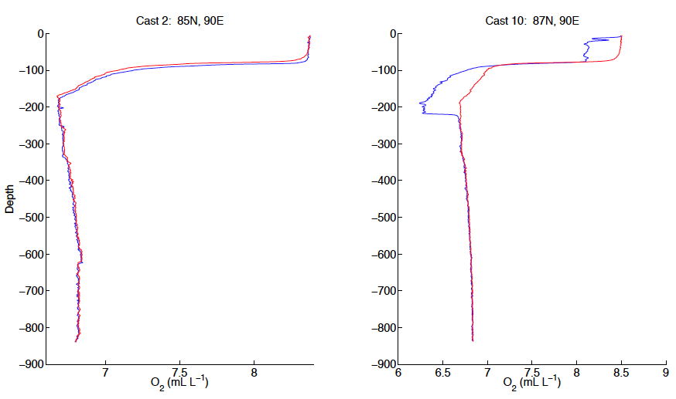

**Figure 1.** Vertical profiles of dissolved oxygen for (a) Cast 2, 85N, 90E and (b) Cast 10, 87N, 90E. Downcast data are plotted as solid blue lines whereas upcast data are plotted as red lines. The negative bias in the dissolved oxygen concentration profile acquired during the downcast that was observed in Casts 6-14 is exhibited in the right panel (Cast 10). The overlap of the O2 data for both downcast and upcast deeper than ~250 m in the right-hand panel suggests whatever problem responsible for the negative bias was temporarily alleviated once the sensor packaged reached greater depth.

Despite these issues, we are confident in the data quality of the measurements collected during the upcasts. Linear regressions between bottle-derived O2 concentrations and sensor-based measurements from downcast O2 (Casts 1-5) and upcast O2 (Casts 6-14) yielded correlation coefficients (R2) of 0.95 (CTD O2 = 0.9357*Bottle O2 + 0.347) and 0.99 (CTD O2 = 1.0594*Bottle O2 - 0.5428), respectively. Furthermore, additional comparisons between upcast data acquired using the 5076-0229 package and downcast data using the 4000-1406 package (deployed immediately following the 5076-0229 casts) at stations Brno (Cast 12), NP (Cast 13), and 89ºN, 90ºE (Cast 14) were favorable in both the absolute O2 concentrations, shape of the vertical O2 profile, and agreement between plots of salinity versus O2 (Fig. 2). Finally, generally good agreement was observed in the relative alignment of O2 and NO3 features (expected due to the relationship between these two variables through biological production and respiration processes).  
  
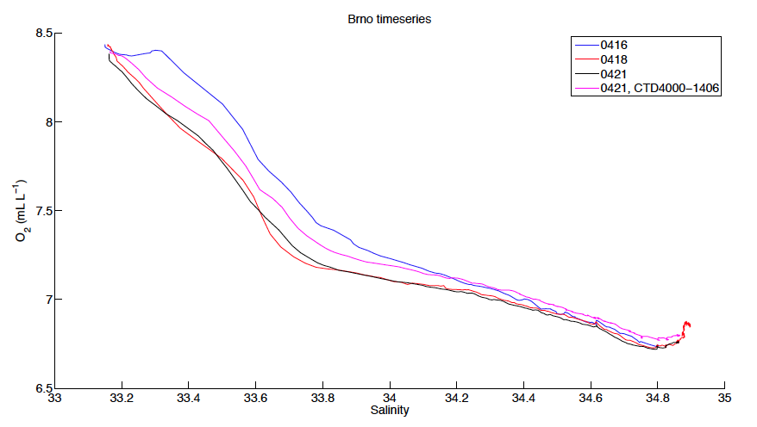**Figure 2.** Plots of dissolved oxygen versus salinity for data collected at station Barneo on April 16 (blue line, Cast 1), April 18 (red line, Cast 7), and April 21 (black and red lines representing successive deployments of the 5076-0229 and 4000-1406 sensor packages, respectively). The shapes of the O2-S curves are all quite similar and the maximum difference among O2 concentrations at any given salinity is ~0.4 mL L-1; however, the comparisons are typically better than 0.2 mL L-1 (the accuracy of O2 measurements is specified to be 0.1 mL L-1 by Seabird).

We leave the choice of correcting the CTD O2 data by applying the regression coefficients derived from linear regressions between CTD and bottle-based measurements of the O2 concentration (given above) to the user.

The final data files each consist of 12 columns of data:

**(1) = Time**

**(2) = Pressure, Strain Gauge [db]**

**(3) = Temperature [ITS-90, deg C]**

**(4) = Depth [salt water, m], lat = 87**

**(5) = Potential Temperature [ITS-90, deg C]**

**(6) = Salinity [PSU]**

**(7) = Potential Density [sigma-theta, kg m-3]**

**(8) = Oxygen [mL L-1]**

**(9) = Oxygen [mmol m-3]**

**(10) = Oxygen [mol kg-1]**

**(11) = oxsat [mL L-1], calculation method: garcia-gordon**

This data was collected under the support of NSF grant OPP-9910335 to K. Falkner and OPP-9910305 to J. Morison. Any opinions, findings, and conclusions or recommendations expressed in this material are those of the author(s) and do not necessarily reflect the views of the National Science Foundation.

For further information, please contact:

Dr. Matthew B. Alkire

[malkire@apl.washington.edu](mailto:malkire@apl.washington.edu)

Polar Science Center, Applied Physics Laboratory

University of Washington

1013 NE 40th Street

Seattle, WA 98105