**Meta Data for 2013 North Pole Environmental Observatory CTD-O2 Profiles collected as part of the aerial hydrographic surveys**

Measurements were collected using a Seabird SBE19*plus* Seacat (serial number 5076) outfitted with an SBE43 O2-sensor (serial number 0229). The SBE43 sensor was plumbed in-line between the TC cell and Seabird 2.0K pump of each instrument. The CTD-O2 package was hung below an in-situ ultraviolet spectrophotomer (ISUS) and battery pack, mounted vertically in a stainless steel frame, using 4-inch, locking carabiners. As a consequence of the physical separation between the thermistor and O2 sensor (as well as the different response times of the two sensors), there is a small lag in time between temperature and O2 measurements of the same water parcel. As a result, the O2 data must be “advanced” in time such that the conductivity (salinity), temperature, oxygen, and nitrate data are correctly aligned relative to pressure. The stations occupied during the 2014 field season of the North Pole Environmental Observatory are listed in Table 1. The complete suite of NPEO 2014 CTD data has been archived separately at CADIS. The files described below can be obtained at: <http://cdp.ucar.edu/browse/browse.htm?uri=http://dataportal.ucar.edu/metadata/cadis/cadis.thredds.xml>. Malfunctions in the ISUS battery pack prevented the collection of quality nitrate data during the 2013 deployment; therefore no ISUS nitrate data are reported.

Casts were begun by lowering the instrument package to a depth of ~15 meters to allow the instruments to come to ambient temperature while attempting to prevent any slush ice being pumped into the system. The package was then brought back up to the near surface and six Niskin bottles were attached to the hydrowire at successive intervals in order to sample the seawater at different target depths (20, 50, 75, 100, 150, and 300 m). Once the Niskin bottles were in position, a soak time of 5 minutes was allowed before tripping the bottles via messenger. The bottles were brought back up to the surface and sub-sampled for a variety of chemical variables. This portion of the cast is referred to as the “bottle cast” and is removed from the archived data files. Once the last Niskin bottle was removed from the hydrowire the winch was re-zeroed while the instrument package was near the surface. The package was then lowered through the water column. This portion of the data record is referred to as the “downcast”. Once the package reached 800-900 m, the winch was stopped and the package brought back up to the surface. This portion of the cast is referred to as the “upcast”. The initial parts of the data during which the CTD was lowered, equilibrated, and raised to the surface have been truncated from the final data files. The final data set reported for each station set consists of either downcast or a combination of downcast and upcast data according to the quality of the data collected (see Table 1).

**Table 1.** Stations occupied during NPEO 2013. The data reported for each cast was either restricted to the downcast or, in some cases, both downcast and upcast data were used (see text for details).

|  |  |  |  |  |  |
| --- | --- | --- | --- | --- | --- |
| **Cast** | **Date** | **Station** | **N Lat**  **(dec. deg)** | **E Lon**  **(dec. deg.)** | **Down or up cast?** |
| 1 | 12-Apr-13 | Brno 1 | 89.273 | -65.522 | down |
| 2 | 14-Apr-13 | 85N, 90E | 84.972 | 89.376 | both |
| 3 | 14-Apr-13 | 86N, 90E | 85.998 | 89.731 | both |
| 4 | 15-Apr-13 | 87N, 90E | 87.009 | 89.837 | both |
| 5 | 15-Apr-13 | 88N, 90E | 88.035 | 89.304 | both |
| 6 | 16-Apr-13 | 89N, 90E | 88.991 | 89.378 | down |
| 7 | 16-Apr-13 | 89N, 180 | 88.957 | -179.268 | down |
| 8 | 17-Apr-13 | 88N, 180 | 88.029 | -179.905 | down |
| 9 | 17-Apr-13 | 87N, 180 | 87.007 | 179.648 | both |
| 10 | 18-Apr-13 | 85N, 170W | 84.923 | -169.838 | down |
| 11 | 18-Apr-13 | 86N, 175W | 86.069 | -173.922 | both |
| 12 | 19-Apr-13 | 90N | 89.961 | -175.174 | both |
| 13 | 19-Apr-13 | 88.5N, 90W | 88.522 | -88.223 | down |

The 4 Hz raw data consisted of scan number, pressure, temperature (ITS-90), conductivity, and SBE43 oxygen sensor voltage. The data were processed using SBEDataProcessor (Version 7.12) according to the following steps:

(1) The raw data was converted using appropriate configuration (CON) file such that the output variables included time, pressure, temperature, conductivity, and SBE43 voltage. Hysteresis and tau corrections were applied to SBE43 voltage data with a 2-sec window.

(2) The temperature and conductivity data were then filtered using a 0.5 second low pass filter whereas the pressure and SBE43 voltage were smoothed using a 1.0 second low pass filter, in accordance with Seabird’s recommendations for SBE19 *plus* data processing.

(3) The temperature records were advanced 0.55 seconds with respect to pressure, as determined by Roger Andersen (APL-UW) on the basis of salinity spiking minimization (Seabird recommends an advance of 0.5 seconds due to the relatively slow response of the temperature sensor with respect to those of the conductivity and pressure sensors; it is possible the cold Arctic environment resulted in a slightly slower than usual sensor response). The SBE43 voltage was advanced 2.5 seconds relative to pressure to account for the lag time between the flow of the sample from the thermistor to the O2 sensor.

(4) Cell thermal mass corrections (alpha = 0.025, tau = 9.0) were applied.

(5) Additional variables were derived from the processed data, including depth (salt water, m) computed assuming a constant latitude of 87ºN, potential temperature (ITS-90, deg C), salinity, potential density (sigma-theta, kg m-3), and dissolved oxygen concentration (mL L-1). The oxygen concentration was calculated using the Murphy-Larson equation, incorporating a cubic temperature correction and a feature-sharpening term (*tau*) involving the time derivative of SBE43 voltage.

(6) For stations where the oxygen concentrations recorded during the downcast exhibited a negative bias (Casts 2, 3, 4, 5, 9, 11, 12; see Table 1), upcast data were reported. However, the upcast data were only reported for the specific depth range in which the downcast data were erroneous (i.e., after removing the data with negative bias from the downcast, upcast data were used to fill in the gaps). In other words, data collected during the upcasts were used to “patch” the downcast (see Fig. 1). This step was necessary because the oxygen concentrations recorded during the upcasts also exhibited biases, but these were observed in the shallowest depth range (0-100 m).

An additional advance was necessary to properly align the data acquired during the upcast relative to pressure. Typically, the movement of the instrument package upward through the water column results in the displacement of water parcels immediately surrounding the instrument(s). This is referred to as the wake effect and results in an offset between data acquired during the downcast versus the upcast (relative to pressure). To correct for this wake effect, the dissolved oxygen was advanced by an additional 3.0 seconds relative to pressure. This advance was computed as 2 x 1.5 sec., where the 1.5 sec. advance was determined as the mean advance necessary to superimpose the downcast and upcast temperature records. This advance is necessary because both the downcast and upcast records are shifted during the calculation of the 1.5 sec. advance. Therefore, the advance necessary to overlay the upcast and the initial downcast (prior to any advancement) is 1.5 + 1.5 = 3.0 seconds. In other words, the advanced upcast data should be aligned (relative to pressure) exactly as the downcast data. Oxygen concentrations from this advanced upcast data were used to “patch” portions of the downcast that exhibited significant negative bias in Casts 2, 3, 4, 5, 9, 11, and 12 (e.g., see Fig. 1). Therefore, both downcast and upcast data were merged together to construct the final data file published for these casts (see Table 1).

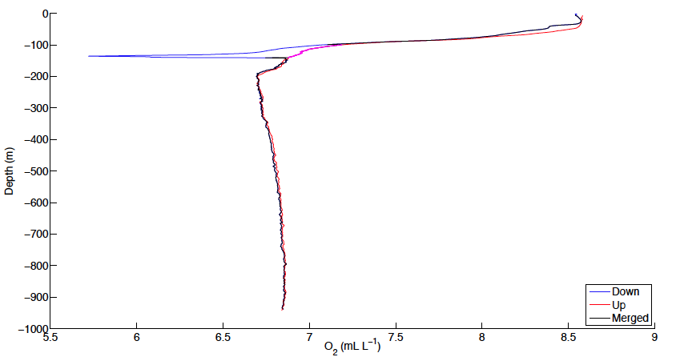

**Figure 1.** Vertical profiles of dissolved oxygen measured during the down (blue) and up (red) casts at station 87N, 90E during NPEO 2013. The Merged profile (black) substitutes data collected during the upcast (highlighted by magenta dots) for the negatively biased data recorded during the downcast. Merged data are reported for Casts 2, 3, 4, 5, 9, 11, and 12 (Table 1).

*Comparison between CTD and bottle oxygen concentrations*

The oxygen concentrations measured by the Seabird SBE43 sensors agreed well with those derived from discrete samples collected using the Niskin bottles and analyzed using the Winkler method (Fig. 2). This good agreement suggests the sensor-based data can be used without adjustment to the factory calibration coefficients. However, the constant offset of 0.24 mL L-1 suggests the sensor data may underestimate the true oxygen concentrations by this amount. According to specifications published by the manufacturer, oxygen concentrations measured by the sensor should be accurate to within ± 0.1 mL L-1. We have not applied a correction to the oxygen concentrations derived from the sensor but instead leave the decision whether or not to correct for this apparent offset to the user.

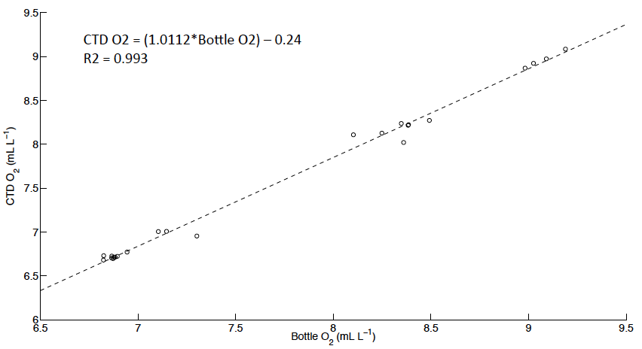

**Figure 2.** Linear regression of oxygen concentrations derived from discrete samples collected from Niskin bottles and analyzed using the Winkler method (x-axis) against concentrations measured by Seabird SBE43 sensors (y-axis).

The final data files each consist of 12 columns of data:

**(1) = Scan**

**(2) = Pressure, Strain Gauge [db]**

**(3) = Temperature [ITS-90, deg C]**

**(4) = Depth [salt water, m], lat = 87**

**(5) = Potential Temperature [ITS-90, deg C]**

**(6) = Salinity [PSU]**

**(7) = Potential Density [sigma-theta, kg m-3]**

**(8) = Oxygen [mL L-1]**

**(9) = Oxygen [mmol m-3]**

**(10) = Oxygen [mol kg-1]**

**(11) = oxsat [mL L-1], calculation method: garcia-gordon**

This data was collected under the support of NSF grant OPP-0634122 to K. Falkner and OPP-9910305 to J. Morison. Any opinions, findings, and conclusions or recommendations expressed in this material are those of the author(s) and do not necessarily reflect the views of the National Science Foundation.

For further information, please contact:

Dr. Matthew Alkire

[malkire@apl.washington.edu](mailto:kfalkner@coas.oregonstate.edu)

(206) 896-1623

Applied Physics Laboratory

University of Washington

1013 NE 40th Street

Seattle, WA 98105