**Meta Data for North Pole Environmental Observatory 2012 ISUS Nitrate Survey**

Measurements were collected using two Seabird SBE19*plus* Seacats (serial numbers 5076 and 4000), each outfitted with an SBE43 O2-sensor (serial numbers 0229 and 1406, respectively). The SBE43 sensors were plumbed in-line between the TC cell and Seabird 2.0K pump of each instrument. The CTD-O2 package was hung below an in-situ ultraviolet spectrophotomer (ISUS) and battery pack, mounted vertically in a stainless steel frame, using 4-inch, locking carabiners. During Casts 1-12, the ISUS was fitted with a sample volume accessory allowing the pumped seawater outflow from the CTD-O2 package to be routed directly to the optical probe of the ISUS via a ~0.9 m length of Tygon tubing. As a consequence of the physical separation between the thermistor and O2 sensor (as well as the different response times of the two sensors), there is a small lag in time between temperature and O2 measurements of the same water parcel. Similarly, there is a longer lag between temperature and nitrate measurements made by the ISUS. As a result, the O2 and NO3 data must be “advanced” in time such that the conductivity (salinity), temperature, oxygen, and nitrate data are correctly aligned relative to pressure. The stations occupied during the 2012 field season of the North Pole Environmental Observatory as well as a summary of the advances computed to properly align the NO3 data are listed in Table 1. The complete suite of NPEO 2012 Nitrate data has been archived separately at CADIS. The files described below can be obtained at:

<http://cdp.ucar.edu/browse/browse.htm?uri=http://dataportal.ucar.edu/metadata/cadis/cadis.thredds.xml>.

The CTD-O2 data processing steps are described separately in the README file accompanying those data and will not be repeated here. These data can also be accessed at CADIS.

Casts were begun by lowering the instrument package to a depth of ~15 meters to allow the instruments to come to ambient temperature while attempting to prevent any slush ice being pumped into the system. The package was then brought back up to the near surface and six Niskin bottles were attached to the hydrowire at successive intervals in order to sample the seawater at different target depths (20, 50, 75, 100, 150, and 300 m). Once the Niskin bottles are in position, a soak time of 5 minutes is allowed before tripping the bottles via messenger. The bottles are brought back up to the surface and sub-sampled for a variety of chemical variables. This portion of the cast is referred to as the “bottle cast” and is removed from the archived data files. Once the last Niskin bottle is removed from the hydrowire the winch is re-zeroed while the instrument package is near the surface. The package is then lowered through the water column. This portion of the data record is referred to as the “downcast”. Once the package reaches 800-900 m, the winch is stopped and the package is brought back up to the surface. This portion of the cast is referred to as the “upcast”. The initial parts of the data during which the CTD was lowered, equilibrated, and raised to the surface have been truncated from the final data files. This order of operations was found to be optimal for ISUS measurement as it allowed sufficient time for the instrument to warm up and equilibrate with its environment. The final data set reported for each station set consists of either downcast or upcast data according to the quality of the data collected (see Table 1).

**Table 1.** Summary of ISUS data collected during 2012 season of the North Pole Environmental Observatory. Advances of temperature and oxygen represent the time (seconds) necessary to shift the corresponding records (relative to pressure) such that the downcast and upcast data are superimposed. Further details regarding the calculation of the advances are given in the text. Gray bars highlight data collected using CTD-O2 package 4000-1406 whereas all other data collected using the 5076-0229 package.

|  |  |  |  |  |  |  |  |
| --- | --- | --- | --- | --- | --- | --- | --- |
| **Cast** | **Date** | **Station** | **Temp. Adv.** | **ISUS Adv.** | **App. ISUS Adv.** | **Cast Reported** | **Pumped?** |
| 1 | 04/16/12 | Brno 1 | 1.25 | 8.0 | 6.8 | down | Yes |
| 2 | 04/16/12 | 85N, 90E | 1.25 | 8.0 | 6.8 | down | Yes |
| 3 | 04/16/12 | 86N, 90E | 1.25 | 5.4 | 6.8 | down | Yes |
| 4 | 04/17/12 | 85N, 170 | 1.25 | 9.4 | 6.8 | down | Yes |
| 5 | 04/17/12 | 86N, 175 | 2.00 | 10.7 | 6.8 | down | Yes |
| 6 | 04/18/12 | 88N, 180 | 1.50 | 21.4 | 9.8 | up | Yes |
| 7 | 04/18/12 | Brno 2 | 1.50 | 24.1 | 9.8 | up | Yes |
| 8 | 04/19/12 | 87N, 180 | 1.25 | 24.1 | 9.8 | up | Yes |
| 9 | 04/19/12 | 89N, 180 | 1.00 | 18.7 | 9.8 | up | Yes |
| 10 | 04/20/12 | 87N, 90E | 1.50 | 24.1 | 9.8 | up | Yes |
| 11 | 04/20/12 | 88N, 90E | 1.00 | 21.4 | 9.8 | up | Yes |
| 12 | 04/21/12 | Brno 3 | 1.50 | 0.00 | 3.00 | up | No |
| 13 | 04/22/12 | NP | 1.00 | 0.00 | 3.00 | up | No |
| 14 | 04/22/12 | 89N, 90E | 1.50 | 0.00 | 3.00 | up | No |
| 12b* | 4/21/12 | Brno 3 | 1.25 | 0.00 | 0.00 | down | No |
| 13b* | 4/22/12 | NP | 1.00 | 0.00 | 0.00 | down | No |
| 14b* | 4/22/12 | 89N, 90E | 1.25 | 0.00 | 0.00 | down | No |

*The final three casts were repeated using a different CTD-O2 package (4000-1406).

Details regarding ISUS data processing have been previously reported in Alkire et al. (2010). Here the data processing steps are briefly described. Since the ISUS does not record pressure or external temperature, the separate ISUS and CTD casts were merged after collection using the respective internal timestamps of their first data record. This synchronization did not include the advance in time required to account for the lag in nitrate data due to the time it took the seawater to flow from the intake of the CTD sensors to the ISUS sample volume. When the seawater inflow to the ISUS is plumbed to the outflow of the CTD-O2 package, the optical probe of the ISUS is located downstream (and above) both the thermistor and SBE43 oxygen sensor. For this reason, the ISUS data record must be advanced relative to pressure such that the NO3 measurements correspond with the temperature, conductivity, and oxygen measurements recorded by the CTD for the same water volume. As noted above, hysteresis of temperature versus pressure is commonly observed when comparing downcasts and upcasts. This can result from a combination of factors such as the wake effect and internal waves that may vary from cast to cast.

The optimal advance was determined by visually aligning features exhibited in the temperature profiles (e.g., minima and/or maxima) between the downcast and upcast. For each iteration, the combined data record (downcast and upcast) was advanced between -10 and +10 seconds (in 0.25 second intervals) and the separate downcast and upcast profiles plotted against pressure. The advancement resulting in the best alignment was selected be eye and chosen as the optimal advance. In some cases visual alignment was difficult due to a lack of prominent features in the temperature record. Whenever this occurred, successive differences (i.e., Ti – Ti-1) were plotted versus pressure. Peaks in these differences, representing sudden large changes in temperature (e.g., thermocline, transition between layers of relatively warm and cold waters) were visually aligned to determine the optimum advance. Comparisons of these two methods consistently returned similar results. An identical procedure was applied to the ISUS data, resulting in the coincidence of the downcast and upcast NO3 concentrations for each cast. The determined advances for temperature and NO3 are listed in Table 1.

In principle, the ISUS measurements are subject to the same advance (wake effect plus internal waves) as the temperature plus an additional advance that accounts for the lag time between temperature and NO3 measurements resulting from the physical separation between the sensors. Therefore, the **advance applied to the ISUS data for Casts 1-5 was equal to the difference between the mean NO3 advance minus the mean temperature advance: 8.3 – 1.5 = 6.8 sec. However,** for stations where the downcast data were compromised (further details given in the next section), the upcast data were reported (Casts 6-14). For these casts, an additional advance was necessary to properly align the data acquired during the upcast relative to pressure. Typically, the movement of the instrument package upward through the water column during the upcast results in the displacement of water parcels immediately surrounding the instruments. This is referred to as the wake effect and results in an offset between data acquired during the downcast versus the upcast (relative to pressure). To correct for this wake effect, the ISUS data were advanced by an additional 3.0 seconds relative to pressure. This advance was computed as 2 x 1.5 sec., where the 1.5 sec. advance was determined as the mean advance necessary to superimpose the downcast and upcast temperature records (see Table 1). This advance is necessary because both the downcast and upcast records are shifted during the calculation of the 1.5 sec. advance. Therefore, the advance necessary to overlay the upcast and the initial downcast (prior to any advancement) is 1.5 + 1.5 = 3.0 seconds. In other words, the advanced upcast data should be aligned (relative to pressure) exactly as the downcast data. For Casts 6-11, the advance applied to the NO3 data was therefore 6.8 + 3.0 = 9.8 sec. For Casts 12-14, only the 3.0 sec. advance was applied (no additional advance is necessary because the ISUS inflow was not connected to the CTD-O2 outflow). For Casts 12b, 13b, and 14b, no advance was applied because the downcast data were reported.

Following synchronization, the resulting data files were then processed using a program (ISUSDataProcessor) developed by Ken Johnson (MBARI), which incorporates salinity and temperature data from the CTD and applies algorithms that correct the spectral data collected by the ISUS for temperature effects on the bromide absorption [*Sakamoto et al*., 2009]. Each nitrate concentration calculated has an associated fit-error (RMS deviation of observed nitrate absorbance from modeled values). Any concentrations with fit-errors exceeding 0.002 were omitted from the final data files to accommodate known instrumental noise (Ken Johnson, personal communication).

Finally, ISUS-derived NO3 concentrations were compared to those measured from seawater samples collected at various depths during each station occupation using simple linear regression. Separate regressions were conducted for the various sets of casts (Table 2). The coefficients yielded from the regressions were used to correct the full downcast or upcast profile of the associated ISUS data. Both “uncorrected” and “corrected” ISUS data are reported in the final data files.

**Table 2.** Regression coefficients derived from simple linear regressions of bottle NO3 concentrations (*x*-variable) versus ISUS-derived NO3 concentrations (*y*-variable) for groups of casts separated according to whether the downcast or upcast is reported and whether the ISUS was (or was not) connected to the CTD-O2 outflow.

|  |  |  |  |
| --- | --- | --- | --- |
| **Casts** | **Slope** | **Intercept** | **R2** |
| 1-5 | 0.8132 | 1.9367 | 0.9885 |
| 6-11 | 0.8622 | 1.1992 | 0.9739 |
| 12-14 | 0.851 | 1.6632 | 0.9863 |
| 12-14b | 0.8697 | 1.4047 | 0.9812 |

*Problems with Casts 6-14*

The 5076-0229 CTD-O2 package recorded quality oxygen data on both the downcast and upcast during Casts 1-5; therefore the downcast data are reported for these casts. However, a negative bias was observed during the downcasts of Casts 6-14 that was not encountered in the upcast data records. We do not have a satisfactory explanation for the cause of the sensor bias during these casts. However, we did observe a significant increase in the offset between downcast and upcast NO3 profiles recorded by the ISUS that was coincident with the biased O2 data (Fig. 1). Assuming these two issues are linked, we have outlined the following hypothesis. We speculate that slush ice may have been introduced into the sample stream when the instrument package was brought to the near surface following the bottle cast and just prior to the downcast. We further suggest this ice blocked or slowed exchange through the O2 sensor membrane. Dissolved oxygen in seawater must diffuse through the sensor membrane to react with an internal electrode, resulting in the donation of electrons. The donation of four electrons per molecule of oxygen is counted per second, recording a voltage that is calibrated to determine the oxygen concentration of the seawater sample. The sensor requires flushing in order to record accurate data; therefore, the lower O2 recorded during the downcasts may have therefore resulted from slush ice interfering with exchange through the sensor membrane. As the instrument package moved deeper through the water column, the increase in pressure and temperature likely melted the ice, clearing obstructions to the membrane and improving the flow rate. Hence, the upcasts were unaffected by this issue and returned quality measurements.

If seawater flow was reduced through the CTD-O2 system, the reduced flow might have been exacerbated along the length of Tygon tubing connecting the ISUS to the CTD-O2 outflow, resulting in the larger offset observed between downcast and upcast NO3 profiles. However, if such a reduction in flow did occur, one would expect a certain degree of smearing in the downcast NO3 data as well as a longer lag (higher advance) between temperature and NO3 measurements collected during the downcast versus those collected during the upcast. Examination of the data did not reveal any obvious smearing or significant differences in flow rates; however, such investigations were quite difficult with the available data and we therefore must admit that such attempts were not conclusive. There are a number of alternative explanations that might account for the negative bias in the downcast O2 concentrations, including a variety of internal issues with the sensor. However, there are fewer likely explanations for the larger offset observed in the ISUS NO3 profiles. One possible explanation could be some discrepancy between the ISUS and CTD internal clocks, a scenario that would influence the time synchronization of the two data records. However, the plumbing between the CTD-O2 system and the ISUS was disconnected for Casts 12-14 and the NO3 profiles did not exhibit the large offset between downcast and upcast NO3.

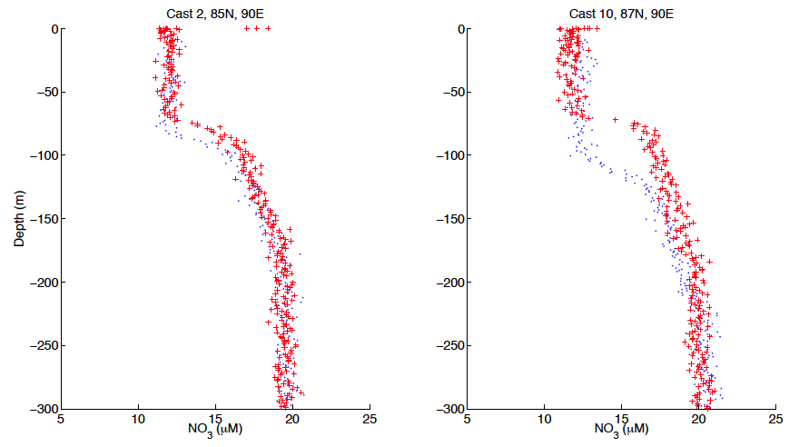

**Figure 1.** Vertical profiles of nitrate for (a) Cast 2, 85N, 90E and (b) Cast 10, 87N, 90E. Downcast data are plotted as solid blue dots whereas upcast data are plotted as red pluses. The larger gap between the downcast and upcast nitrate data, typical of Casts 6-11, is clearly evident in the right panel (Cast 10) compared to the left panel (Cast 2).

Despite these issues, we are confident in the data quality of the measurements collected. Linear regressions of bottle NO3 versus ISUS NO3 concentrations returned high correlation coefficients and relatively low intercepts (< 2 mM). Furthermore, additional comparisons between upcast data acquired using the 5076-0229 package and downcast data using the 4000-1406 package (deployed immediately following the 5076-0229 casts) at stations Brno (Cast 12), NP (Cast 13), and 89ºN, 90ºE (Cast 14) were favorable in both the absolute NO3 concentrations, shape of the vertical NO3 profile, and agreement between plots of salinity versus O3 (Fig. 2). Finally, generally good agreement was observed in the relative alignment of O2 and NO3 features (expected due to the relationship between these two variables through biological production and respiration processes).

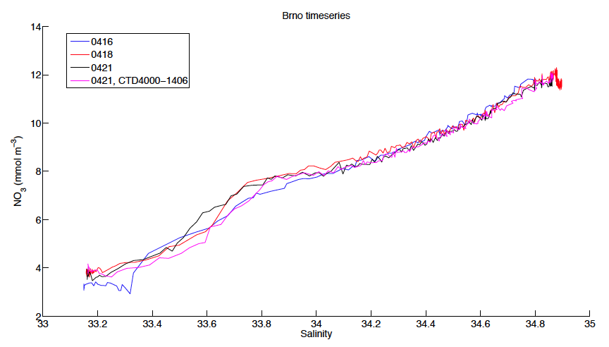

**Figure 2.** Plots of nitrate versus salinity for data collected at station Barneo on April 16 (blue line, Cast 1), April 18 (red line, Cast 7), and April 21 (black and red lines representing successive deployments of the 5076-0229 and 4000-1406 sensor packages, respectively). The shapes of the NO3-S curves are all quite similar and the maximum difference among NO3 concentrations at any given salinity is < 2 mM (the accuracy of the V2 ISUS specified by the manufacturer, Satlantic).

The final data files are tab-delimited ASCII text files, each consisting of 12 columns of data:

**(1) = Pressue [db]**

**(2) = Depth [salt water, m]**

**(3) = Temperature [ITS-90, deg C]**

**(4) = Potential Temperature [ITS-90, deg C]**

**(5) = Salinity [PSU]**

**(6) = Potential Density [sigma, kg m-3]**

**(7) = Dissolved Oxygen [mL L-1]**

**(8) = Dissolved Oxygen [mmol m-3]**

**(9) = Dissolved Oxygen [mmol kg-1]**

**(10) = Oxygen Percent Saturation [%]**

**(11) = Nitrate, uncorrected [M]**

**(12) = Nitrate, corrected [M]**

This data was collected under the support of NSF grant OPP-0634122 to K. Falkner and OPP-9910305 to J. Morison. Any opinions, findings, and conclusions or recommendations expressed in this material are those of the author(s) and do not necessarily reflect the views of the National Science Foundation.

For further information, please contact:

Dr. Matthew Alkire [malkire@apl.washington.edu](mailto:kfalkner@coas.oregonstate.edu) (206) 896-1623

Applied Physics Laboratory

University of Washington

1013 NE 40th Street

Seattle, WA 98105

References

Alkire, M.B., K.K. Falkner, J. Morison, R.W. Collier, C.K.Guay, R.A. Desiderio, I.G. Rigor, M. McPhee (2010). Sensor-based profiles of the NO parameter in the central Arctic and southern Canada Basin: new insights regarding the cold halocline, *Deep-Sea Research I 57:* 1432-1443.

Sakamoto, C.M., K.S Johnson, L.J. Coletti (2009). Improved algorithm for the

computation of nitrate concentrations in seawater using an in situ ultraviolet spectrophotometer, *Limnology & Oceanography: Methods 7*, 132-143.